PRACTICAL 9-

Step 1:
Download PyCharm
Open your browser and go to
https://www.jetbrains.com/pycharm/
Click Download
Step 2:
Choose:
PyCharm Community ✅ (Free, best for learning & teaching)
Step 3:
Click Download under Community.updat ebin
Creating new file in pycharm

Step 4:
In Welcome screen
- Click New Project
- Select Pure Python
- Choose Location (default is OK)
- Under Python Interpreter:
  - Select Existing Interpreter
  - Choose your installed Python 3.x
- Click Create

Step 6:
Chk-file-settings-python-intrepretor-python3.12(select urversion)
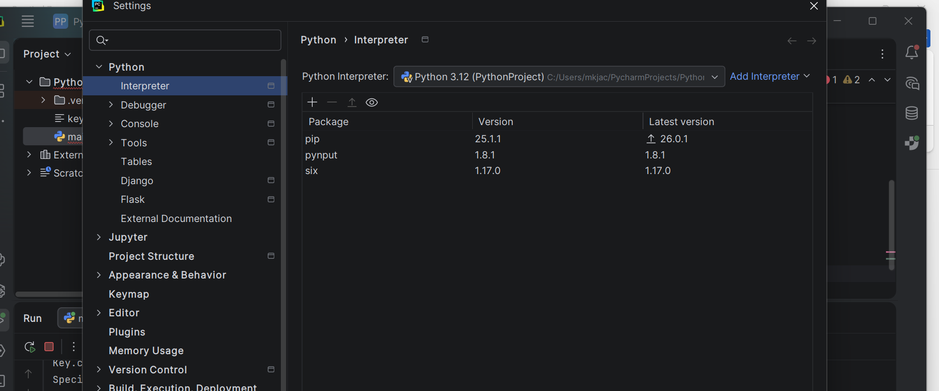

Step 7:
TYPE CODE &
run the program..

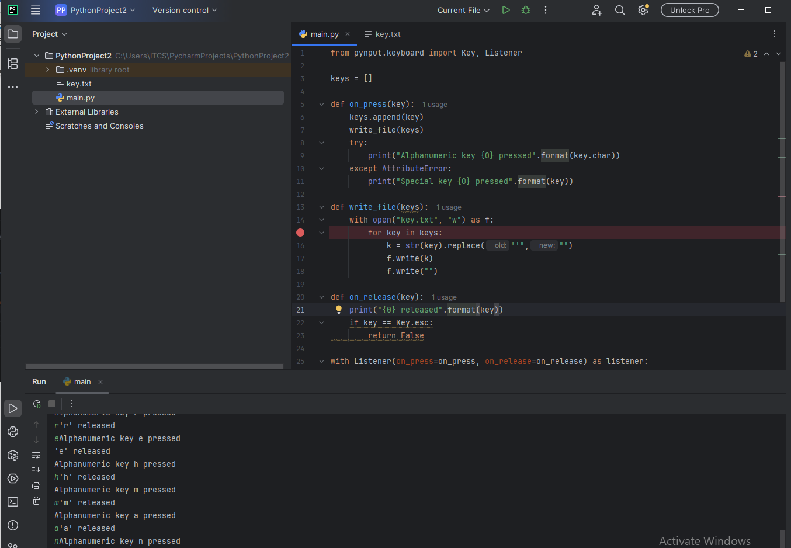

o/p




